Mid-Semester Report, Semester 2, 2018

ANU Student Managed Fund

Creation Date: 4/09/2018 | Version Date: 26/09/2018 (Final)

Contents
Glossary 2
About this Report 3
Chief Investment Officer Report 3
Team Update 4
Active Stock Positions 6
Telstra
Rio Tinto
Portfolio Overview 7
Socially Responsible Investment (SRI) Report 10

Glossary
AA – Asset Allocation
AAE – Active Australian Equities
ANU – The Australian National University
CIO – Chief Investment Officer
ESG – Environmental, Social and Governance
ETF – Exchanged-Traded Fund
IAC – Investment Advisory Committee
IP – Investment Process
LTIP – Long Term Investment Pool
SMF – Student Managed Fund
SRI – Socially Responsible Investment
R&C – Risk and Compliance
RIO – Rio Tinto Limited
TLS – Telstra Corporation Limited

About this Report
The ANU Student Managed Fund is proud to report on the activities and achievements of the SMF over the first half of Semester 2, 2018. The report includes an update from the CIO, an introduction of new members in the SMF and an analysis from the AAE team regarding the SMF’s investments. We report on performance, including an attribution analysis of performance versus the benchmark, as well as provide a statement of SRI compliance. The SMF team will produce shorter abridged reports at mid-semester, and more comprehensive reports at end-semester that include commentary written by all team leaders.
We would welcome feedback and the opportunity to address any further enquiries, which can be directed to the SMF email address (smf.rsfas@anu.edu.au).
Rory Roche & Saurav Patel
Relationship Team

Chief Investment Officer Report
The SMF team consists of 18 members in Semester 2, 2018. Across the whole team, we are tremendously pleased to welcome so many new members who have already made great contributions to the Fund.
As CIO, I have overseen and supported many of these contributions, and significant progress has been made during the semester. The whole team continued to advance our processes, such as continuing to develop the implementation of the ANU SRI policy.
At the sub-team level, the active Australian equities (AAE) team finished their candidate stock analysis and started the in-depth stock analysis with a view to putting new stock recommendations to the IAC. The asset allocation (AA) team achieved great progress in structuring the AA investment process (IP), which they look forward to finalising by the end of the semester. As well as building a portfolio performance attribution model, the risk and compliance (R&C) team has further developed the SRI compliance process and has worked closely with the AAE team to ensure all the stock selection processes align with the CGS and the ANU policy. After consultation and training with ANU communications, the Relationship team is making progress in the creation of an SMF social media policy statement.
During the first half of this semester, David Nolan and Risman Cornelius addressed the SMF as guest speakers. The insight and advice regarding SRI, general industry knowledge and fund management were invaluable for the SMF and its members. We value these contributions very highly and would welcome similar contributions in the future.
In the second half of the semester, we are looking forward to the completion of the AA IP and investment recommendations from the AAE team. Meanwhile, the R&C and Relationship teams are expected to finalise the risk management framework, the SRI policy process and the social media policy statement. With the progress and commitment made by the team already, I believe the group will achieve all of its objectives and aims by the end of the semester.
Ruolin (Alex) Mai, CIO

Team Update
This semester the SMF team expanded to 18 members, with 8 senior members carrying over from the previous semester and the addition of 10 new members. The structure of the SMF, in particular its key value of ‘legacy’, places high importance on teaching, guidance and leadership being passed from senior members to new incoming members. This over-lapping cohort structure enhances the learning outcomes of students and ensures the SMF retains stability and continuity in its operations. Across the SMF, a major theme for the semester has been the effort to contextualise, develop and integrate SRI issues into the Fund. This process has been aided by the contributions of our guest speakers David Nolan and Risman Cornelius, and has resulted in the creation of an SRI compliance process from R&C and a document detailing the integration of SRI into the way that AAE analyses stocks. A brief introduction of the new team members and an indication of the tasks allocated to each is presented below.

AA Team
Joining the AA team as junior analysts are Jak Carty and Hongyi Xu. Under the guidance of AA Team Leaders Victor Munagala and Harrison Papworth, Jak and Hongyi have been assisting with the design of the AA IP and development of the models that will be used to analyse asset classes. They also took it upon themselves to present to the entire SMF team on some of the foundation concepts that will underpin the AA IP. The input of the new junior members is proving highly valuable for the AA team, which has been presented with a steep learning curve given that the team has been unable to draw from conventional courses and has instead started building its IP from scratch.

AAE Team
The AAE team is the most advanced of the four SMF teams, having completed its IP and made initial investments in Rio Tinto and Telstra at the end of Semester 1, 2018. The AAE team has benefitted from the similarity between the AAE analysis and teaching provided in advanced finance courses such as Corporate Valuation. This semester the SMF has welcomed Ruxin (Chasel) Chi, Chuxuan (Jessie) Jiang, Aiyun Li, Jiaqi Liu and Chengxuan (Charles) Zhang as junior analysts in the AAE team. Utilising the knowledge they have acquired from previous courses and the teaching provided by senior AAE team members (Isabella Mortimore, Wayne Wang and Zhan Zhang), the junior analysts have been taking primary responsibility for undertaking stock analysis and writing stock reports. This process is almost completed, with the intention of presenting additional investment proposals to the IAC for endorsement soon.

R&C Team
Azmina Hossain and Saurav Patel (50%) have joined the R&C team as junior analysts. This introduction will assist the R&C team in furthering its progress regarding SRI and Risk Management. The junior analysts, with the assistance of senior team members Lanyu Zhang and Zhongxi Zheng, have been performing risk and SRI evaluation on the stocks selected by AAE for further analysis. Azmina and Saurav have also been advancing the funds internal and external performance reporting, through their work on performance attribution analysis and providing weekly performance updates for the SMF.

Relationship Team
This semester sees the formation of a formal Relationship team, comprising Rory Roche and Saurav Patel (50%), who operate under the guidance of the CRO, Zhongxi Zheng, and SMF CIO Alex Mai (who was the previous Relationship Manager). The expansion of the relationship function out from within the R&C team reflects the importance the Fund places on the communication of its activities and values, and on attracting top students to continue the legacy of the SMF. The team are developing the SMF’s external communications, and will look to advance this process with the creation of a social media policy statement. They also provide ongoing administrative support by preparing meeting minutes and SMF reports.

SMF Team
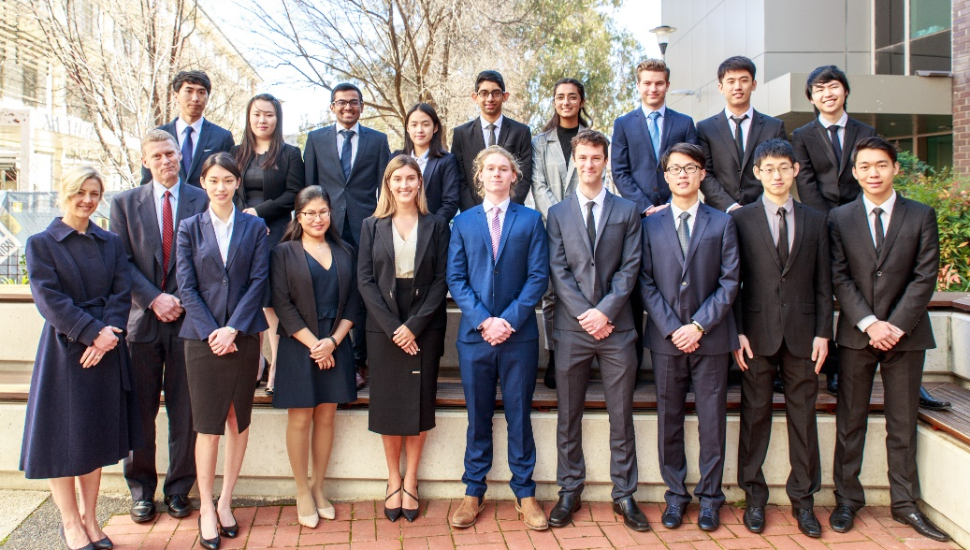

Active Stock Positions
The Active Australian Equities team was tremendously pleased to have produced the SMF’s first set of investment recommendations towards the end of last semester. These recommendations represent our efforts to advance our fund’s core investment objectives and improve the long-term risk-return trade-off of our portfolio. They involved purchasing Telstra (ASX: TLS) and Rio Tinto (ASX: RIO) in the AAE portfolio, funded by reducing holdings in the iShares Core S&P/ASX200 ETF.
The recommendations were endorsed by the IAC, and subsequently implemented with a target weight of 6% and 3% for Telstra and Rio Tinto, respectively. The weightings assigned to these investments were based on the attractiveness of their risk-return profiles, the SRI policy of the fund, and the advice provided by members of the IAC. While there have been no new acquisitions or disposals to report at this stage, the AAE team would like to provide further insight into its holdings of Telstra and Rio Tinto.

Telstra
The first active security to enter the portfolio was Telstra, Australia's largest telecommunications company, which builds and operates telecommunications networks and markets voice, mobile, internet access, pay television and other products and services. Our investment thesis was driven by the belief that Telstra had been too heavily discounted by the market notwithstanding its business challenges, made evident by the reactionary drop in the share price following TLS's announcement of a 30% cut in dividend payout. Further, any upside from the new reinvestment strategy (moving towards technology and cybersecurity fields) was not priced into the market, providing the possibility of some upside. We were also attracted by the historically high-quality nature of the business which, supported by a robust financial position, provides an opportunity for solid cash flow generation and fully-franked dividends over the long run – valuable features given the objectives of the fund.

Rio Tinto
Our second recommendation was in Rio Tinto, a large and global diversified mining company with operations in the production of iron ore, aluminium and other basic materials and metals. We put forward an investment thesis built on the company’s high-quality asset base, operational efficiency and cost leadership; with the expectation of strong and sustainable cash flow generation. Our analysis, entailing a quantitative discounted cash flow valuation and a qualitative assessment of economic fundamentals, provided indications that the company would benefit the SMF portfolio through its favourable base valuation and attractive upside potential.
Zhan Zhang, Head of AAE

Portfolio Overview
In providing such information on asset allocation and performance, it is worth reiterating the long-term objectives of the SMF. The SMF strives to maximise the long-term trade-off between the expected value of funds invested, against the risk of sustained reduction in the real value of the portfolio. The aim is to support the real value of its philanthropic activities in perpetuity, i.e. maintain the real value of the fund and its distributions over the long run.
This report reflects portfolio data as at 31 August 2018, with performance struck over the period since 9 June 2018, which was the basis for the report for End-Semester 1 2018. Asset allocation data for 9 June and 31 August are presented in Figure 1 and Figure 2, respectively. Minor changes in asset allocation have occurred as a result of differing performance of the asset classes acting to shift the weights, rather than deliberate asset allocation decisions. The SMF monitors these deviations and has appropriate policies in place if rebalancing is required.
Figure 1: Asset Allocation as at 9/6/2018

Figure 2: Asset Allocation as at 31/8/2018

Figure 3 details the investments and total performance since the last report. Over this period, the SMF portfolio achieved a return of 5.08%. The SMF portfolio holds an 80.50% exposure to equity and thus has benefited from the strong performance of equity markets since the Fund’s investment in the reference portfolio on 16 April 2018. While these short-term returns are positive, such performance, particularly in equity markets, is subject to fluctuations and thus these returns are assessed against the context of the Fund’s long-term objectives. In this regard, all we can say is that these returns have enhanced the funds progress in funding its philanthropic activities in perpetuity at this time.
Figure 3: Portfolio Structure at 31 August 2018, and Performance since 9 June 2018
Portfolio Component | Benchmark ETF | Opening Balance (9/6/2018) | Closing Balance (31/8/2018) | Reference Weights | Portfolio Weights (31/8/2018) | Return
 |  | $ | $ | % | % | %
Australian Equities
iShares Core S&P/ASX 200 |  | 357,421 | 374,835 |  | 55.90 | 5.90
Telstra | - | 19,360 | 21,666 |  | 3.23 | 17.59
Rio Tinto | - | 9,872 | 8,292 |  | 1.24 | -13.19
Total Australian Equities | iShares Core S&P/ASX 200 |  |  | 60 | 60.37
International Equities
International Equities, Unhedged | Vanguard International Shares Index | 64,653 | 68,817 | 10 | 10.26 | 7.76
International Equities, Hedged | Vanguard International Shares Index, Hedged | 64,839 | 66,339 | 10 | 9.89 | 3.35
Total International Equities |  |  |  | 20 | 20.15
Total Equities |  |  |  | 80 | 80.52
Australian Fixed Income | Vanguard Australian Government Bond Index | 92,094 | 93,514 | 15 | 13.95 | 2.16
Australian Cash
BetaShares Australia High Interest Cash |  | 16,680 | 16,703 |  | 2.49 | 0.31
BT Cash Management Trust | - | 13,142 | 18,108 |  | 2.70 | 0.00
Accrued Interest, Dividends and Franking Credits | - | 29 | 2,263 |  | 0.34 | 0.00
Total Australian Cash | BetaShares Australia High Interest Cash |  |  | 5 | 5.53
Total Fixed Income & Cash |  |  |  | 20 | 19.48
TOTAL PORTFOLIO |  | 638,092 | 670,539 | 100 | 100 | 5.08
Reference Portfolio Performance |  |  |  |  |  | 5.00
SMF Portfolio vs Reference Portfolio |  |  |  |  |  | 0.08
From Figure 3, the SMF Portfolio return of 5.08% outperforms the reference portfolio by 0.08% in the sub-period from 9 June to 31 August 2018. As part of the process of better understanding the sources of performance and how it relates to our portfolio management process, the R&C team has developed a performance attribution analysis. This analysis decomposes performance relative to the benchmark into contributions from asset allocation and security selection decisions.
The asset allocation contribution is 0.04%, as shown in Figure 4. This contribution arises from the difference in asset allocation between the actual portfolio and the reference portfolio, multiplied by the returns delivered by the benchmark ETFs. Since the AA team is in the process of finalising its IP, the asset allocation contribution is reflective of the portfolio weights drifting away from the SMF reference portfolio weights due to market movements, rather than any active strategic tilts to specific asset classes made by the Fund.
The overall contribution of security selection from the AAE portfolio is 0.12%. Each security’s contribution is calculated by estimating the active security weights within the AAE portfolio and multiplying by the performance differential between the actual security returns and the return on the benchmark S&P/ASX200 ETF. Note the calculations include any franking credits received, and the SMF returns and AAE contributions have benefitted from holding stocks that pay relatively high fully franked dividends (notably Telstra). Franking credits are explicitly taken into account in selecting stocks, given that ANU is able to claim the full value of franking as a tax credit.

Figure 4: Asset Allocation Contribution

Figure 5: Security Selection Contribution

Socially Responsible Investment (SRI) Report
SRI was a major point of focus during this semester, with some significant changes being made to how the ANU SRI policy is to be implemented within the SMF looking forward. To date, SRI compliance for the SMF has been drawn from the manner in which the ANU SRI policy is being applied within the Australian equities portfolio of the ANU’s Long-Term Investment Portfolio (LTIP). This requires the ANU’s (enhanced index) Australian equity manager to comply with three main conditions:
- Exclude companies that derive more than 20% of revenues from coal, gambling, tobacco or pornography.
- Hold a portfolio with 25% less carbon intensity than the S&P/ASX 200.
- Ensure that the portfolio demonstrates a 10% improvement in the overall ESG rating relative to the benchmark.
The SMF has been aiming to ensure that the active stock positions within the AAE portfolio also comply with these conditions. Figure 6 displays the AAE portfolio as at 31 August 2018, with the relevant carbon intensity and ESG scores utilized for SRI compliance. The carbon intensity scores for both Telstra and Rio Tinto are retrieved from Bloomberg. They are calculated based on the annual carbon emission (in tonnes) per $1 million of revenue earned. The carbon intensity for the S&P/ASX200 ETF is sourced from the ANU Socially Responsible Investment Policy 2017 Report, which was consistent with the most recent data available. The ESG scores are based on analysis performed by Sustainalytics, which remains unchanged from the data presented in the SMF’s End-Semester 1, 2018 report.
Figure 6: Current Position of the AAE Component in regard to SRI Compliance
 | ASX200 ETF | Telstra (TLS) | Rio Tinto (RIO) | Total Active Stock Positions | Active Stock Positions vs. S&P/ASX200 (Benchmark)
Weighting in AAE portfolio | 91.1% | 6.4% | 2.5% | 8.9% | -
Carbon intensity | 314.2 | 50.2 | 557.6 | 190.6 | -39.3%
ESG score | 63.8 | 74.0 | 68.0 | 72.3 | +13.4%
The SMF portfolio has been in compliance with the ANU SRI policy in regard to its holdings in the active investments of Telstra and RIO. This is demonstrated by a -39.3% reduction in carbon intensity against the required -25%, and a 13.4% improvement in ESG score against the required 10%. Once the AAE Portfolio is fully invested in active stock positions, as against its current partial exposure to the S&P/ASX200 ETF, the AAE portfolio will be in complete compliance with these elements of the ANU SRI policy.
The implementation of the ANU SRI policy by the SMF was recently discussed at an IAC meeting on 17 September, 2018. Based on the discussions at this meeting, going forward the AAE team will be integrating broader SRI considerations into its stock selection. In forming investment recommendations to be put to IAC, consideration will be given to whether candidate companies either “cause substantial social injury” or promote “socially beneficial outcomes”, in addition to their impact on the carbon intensity and ESG score for the overall AAE portfolio. It was also decided that the SMF will consider changing its benchmark ETFs to those that reflect the ANU SRI policy, while still providing an adequate representation of the underlying asset class, once suitable ETFs become available. The latter decision was considered an appropriate balance between the SRI policy, fund efficiency, and the learning objectives of the SMF.

ANU SMF / RSFAS / College of Business and Economics
+61 2 6125 4626
SMF email: smf.rsfas@anu.edu.au
The Australian National University
Canberra ACT 2601 Australia
www.anu.edu.au
CRICOS Provider No. 00120C

